**Pizza Sales Report Using MS Excel, SQL, Power BI**

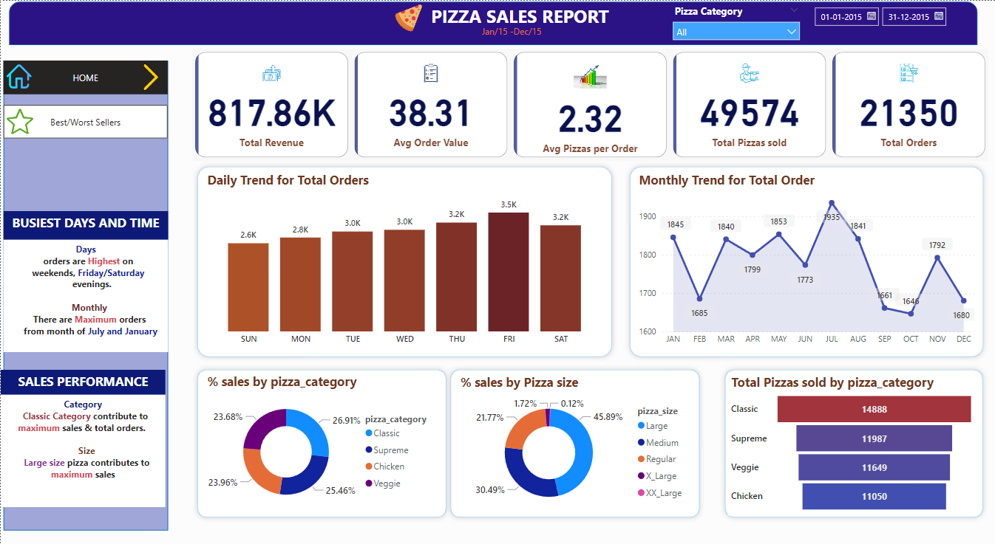

select SUM(total_price) as Total_Revenue from pizza_sales;

select sum(total_price)/COUNT(distinct order_id) as Avg_Order_value from pizza_sales;

select SUM(quantity) as Total_Pizza_sold from pizza_sales;

select COUNT(distinct order_id) as Total_orders from pizza_sales;

select cast(cast(SUM(quantity) AS decimal(10,2))/cast(COUNT(distinct order_id) as decimal(10,2)) as decimal(10,2)) as Average_pizza_per_order from pizza_sales;

select DATENAME(DW, order_date) as order_day, COUNT(distinct order_id) as Total_orders from pizza_sales

group by DATENAME(DW, order_date);

select DATENAME(MONTH, order_date) as Month_Name, COUNT(distinct order_id) as Total_orders

from pizza_sales

group by DATENAME(MONTH, order_date);

select DATENAME(MONTH, order_date) as Month_Name, COUNT(distinct order_id) as Total_orders

from pizza_sales

group by DATENAME(MONTH, order_date)

order by Total_orders desc;

select pizza_category, SUM(total_price)*100 / (select SUM(total_price) from pizza_sales) as PCT

from pizza_sales

group by pizza_category;

select pizza_category, SUM(total_price) as Total_sales, SUM(total_price)*100 /

(select SUM(total_price) from pizza_sales where month(order_date) = 1) as PCT

from pizza_sales

where MONTH(order_date) = 1

group by pizza_category;

select pizza_size, SUM(total_price) as Total_sales, SUM(total_price)*100 /

(select SUM(total_price) from pizza_sales) as PCT

from pizza_sales

group by pizza_size;

select pizza_size, SUM(total_price) as Total_sales, SUM(total_price)*100 /

(select SUM(total_price) from pizza_sales) as PCT

from pizza_sales

group by pizza_size

order by PCT desc;

select pizza_size, cast(SUM(total_price) as decimal(10,2)) as Total_sales, cast(SUM(total_price)*100 /

(select SUM(total_price) from pizza_sales) as decimal(10,2)) as PCT

from pizza_sales

group by pizza_size

order by PCT desc;

select pizza_size, cast(SUM(total_price) as decimal(10,2)) as Total_sales, cast(SUM(total_price)*100 /

(select SUM(total_price) from pizza_sales) as decimal(10,2)) as PCT

from pizza_sales

where DATEPART(QUARTER, order_date) = 1

group by pizza_size

order by PCT desc;

select top 5 pizza_name, SUM(total_price) as Total_Revenue from pizza_sales

group by pizza_name

order by Total_Revenue desc;

select top 5 pizza_name, SUM(total_price) as Total_Revenue from pizza_sales

group by pizza_name

order by Total_Revenue;

